**DATE:18/11/2024**

1. Given an array, **arr[]**. Sort the array using bubble sort algorithm.

**Input**: arr[] = [64, 34, 25, 12, 22, 11, 90];

**Output**: [11 12 22 25 34 64 90];

CODE:

**package** util;

**import** java.util.Arrays;

**public** **class** Bubblesort {

**public** **static** **void** main(String[] args) {

**int** arr[] = {11, 80, 5, 36, 100, 1};

*bubbleSort*(arr);

System.***out***.println(Arrays.*toString*(arr));

}

**public** **static** **void** bubbleSort(**int** arr[]) {

**int** n = arr.length;

**for** (**int** i = 0; i < n - 1; i++) {

**boolean** swapped = **false**;

**for** (**int** j = 0; j < n - i - 1; j++) {

**if** (arr[j] > arr[j + 1]) {

**int** temp = arr[j];

arr[j] = arr[j + 1];

arr[j + 1] = temp;

swapped = **true**;

}

}

**if** (!swapped) **break**;

}

}

}

OUTPUT:

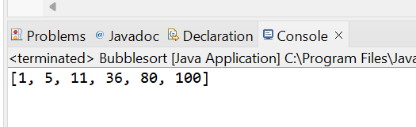

TIME COMPLEXITY:O(n^2)

2. Given a string **s** consisting of **lowercase**Latin Letters. Return the first non-repeating character in **s**. If there is no non-repeating character, return **'$'.**  
Note:When you return '$' driver code will output -1.

CODE:

class Solution {

static char nonRepeatingChar(String s) {

// Your code here

int[] freq = new int[26];

for (char c : s.toCharArray()) {

freq[c - 'a']++;

}

for (char c : s.toCharArray()) {

if (freq[c - 'a'] == 1) {

return c;

}

}

return '$';

}

}

OUTPUT:

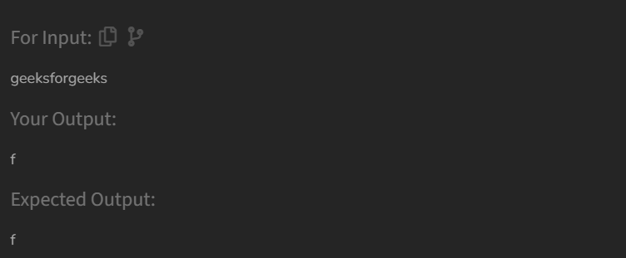

TIME COMPLEXITY:O(N)

3. Replace any character from the string with any other character.

**Input:** s1 = "geek", s2 = "gesek"

**Output:** 1

Explanation:One operation is required, inserting 's' between two 'e'.

CODE:

class Solution {

public int editDistance(String s1, String s2) {

// Code here

int m = s1.length();

int n = s2.length();

int[][] dp = new int[m + 1][n + 1];

for (int i = 0; i <= m; i++) {

dp[i][0] = i; // All deletions

}

for (int j = 0; j <= n; j++) {

dp[0][j] = j;

}

for (int i = 1; i <= m; i++) {

for (int j = 1; j <= n; j++) {

if (s1.charAt(i - 1) == s2.charAt(j - 1)) {

dp[i][j] = dp[i - 1][j - 1];

} else {

dp[i][j] = 1 + Math.min(dp[i - 1][j - 1],

Math.min(dp[i - 1][j],

dp[i][j - 1]));

}

}

}

return dp[m][n];

}

}

OUTPUT:

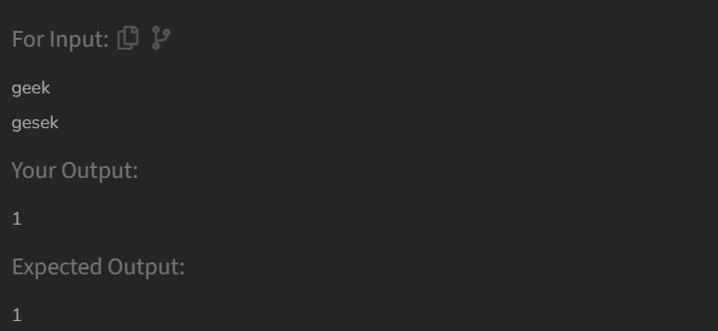

TIME COMPLEXITY:O(m*n)

4. Given an array **arr[]** of positive integers and an integer **k**, Your task is to return **k largest elements**in decreasing order.

**Input:** arr[] = [12, 5, 787, 1, 23], k = 2

**Output:** [787, 23]

**Explanation:** 1st largest element in the array is 787 and second largest is 23.

CODE:

class Solution {

static List<Integer> kLargest(int arr[], int k) {

int n = arr.length;

Integer[] arrInteger =

Arrays.stream(arr).boxed().toArray(Integer[]::new);

Arrays.sort(arrInteger, Collections.reverseOrder());

ArrayList<Integer> res = new ArrayList<>();

for (int i = 0; i < k; i++)

res.add(arrInteger[i]);

return res;

}

}

OUTPUT:

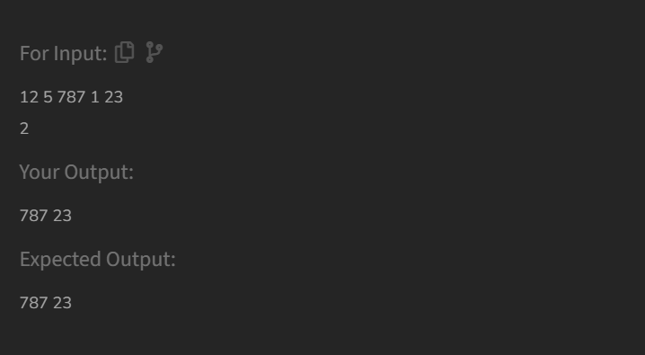

TIME COMPLEXITY:O(n log n)

5. . Given an array of integers **arr[]**representing non-negative integers, arrange them so that after concatenating all of them in order, it results in the **largest**possible**number**. Since the result may be very large, return it as a string.

**Input:** arr[] = [3, 30, 34, 5, 9]

**Output:** "9534330"

**Explanation:** Given numbers are {3, 30, 34, 5, 9}, the arrangement "9534330" gives the largest value

CODE:

class Solution {

String findLargest(int[] arr) {

// code here

String[] strArr = Arrays.stream(arr).mapToObj(String::valueOf).toArray(String[]::new);

Arrays.sort(strArr, new Comparator<String>() {

public int compare(String s1, String s2) {

String order1 = s1 + s2;

String order2 = s2 + s1;

return order2.compareTo(order1);

}

});

if (strArr[0].equals("0")) {

return "0";

}

StringBuilder result = new StringBuilder();

for (String num : strArr) {

result.append(num);

}

return result.toString();

}

}

OUTPUT:

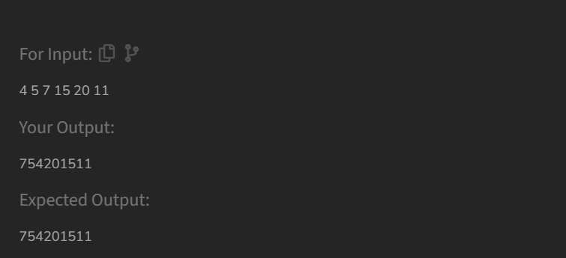

TIME COMPLEXITY:O(n log n)

6. . Implement Quick Sort, a Divide and Conquer algorithm, to sort an array, **arr**[] in ascending order. Given an array, **arr**[], with starting index **low** and ending index **high**, complete the functions **partition()** and **quickSort()**. Use the last element as the pivot so that all elements less than or equal to the pivot come before it, and elements greater than the pivot follow it.

**Note**: The **low** and **high** are inclusive.

**Input:** arr[] = [4, 1, 3, 9, 7]

**Output:** [1, 3, 4, 7, 9]  
**Explanation:** After sorting, all elements are arranged in ascending order.

CODE:

**package** util;

**public** **class** Quicksort {

**static** **int** partition(**int**[] arr, **int** low, **int** high) {

**int** pivot = arr[high];

**int** i = low - 1;

**for** (**int** j = low; j <= high - 1; j++) {

**if** (arr[j] < pivot) {

i++;

*swap*(arr, i, j);

}

}

*swap*(arr, i + 1, high);

**return** i + 1;

}

**static** **void** swap(**int**[] arr, **int** i, **int** j) {

**int** temp = arr[i];

arr[i] = arr[j];

arr[j] = temp;

}

**static** **void** quickSort(**int**[] arr, **int** low, **int** high) {

**if** (low < high) {

**int** pi = *partition*(arr, low, high);

*quickSort*(arr, low, pi - 1);

*quickSort*(arr, pi + 1, high);

}

}

**public** **static** **void** main(String[] args) {

**int**[] arr = {20,40,5,32,9,82,67};

**int** n = arr.length;

*quickSort*(arr, 0, n - 1);

**for** (**int** val : arr) {

System.***out***.print(val + " ");

}

}

}

OUTPUT:

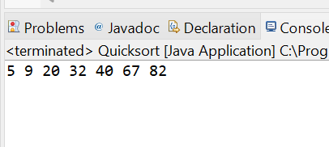

TIME COMPLEXITY: O(n log n)